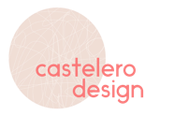

WEB DESIGN PROCESS OVERVIEW

This document outlines the Web Design Process step by step, so you know what to expect.

- Submit Your Content
Fill out the Creative Brief. This will help us understand exactly what you’re looking for in a website.

Pick a Hosting Service

In order to make your website available to the public, you’ll need to choose a platform to build your site on. I can help guide you in picking the right platform for your site and have outlined a few options below.

Hosting Service | Pros | Cons
Wix.com | Drag and drop editor gives you total design freedom. Great for a medium sized site. | They also use third party apps for some advanced features.
Webflow | Great levels of design customization. | A bit more expensive than other hosting services. No live chat or phone support.
Squarespace | Modern design. Great for a simple website. | Limited customization capabilities.
Shopify | Great ecommerce capabilities. Recommended if you want an online store. | Limited design options.
Wordpress | Endless options in terms of site functionality. Great for a larger website that you will constantly be updating/managing. | Requires a lot of maintenance and steep learning curve. No customer service.

Choose a Template

Many of these hosting services offer basic website templates you can choose from which act like the backbone of your site. Pick one which most closely resembles what you want your site to look like.

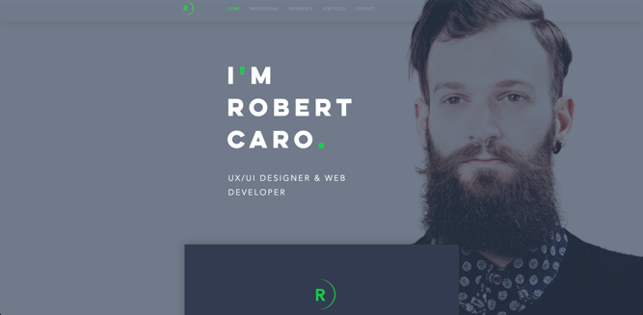 | 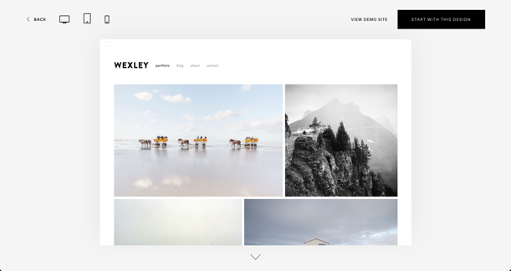
Wix Templates | Squarespace templates

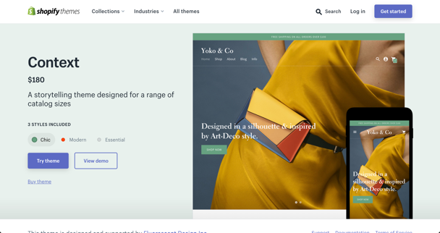 | 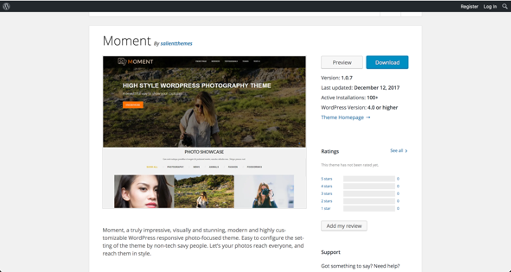
Shopify Templates | Wordpress Templates

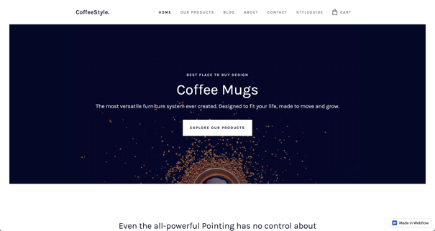
Webflow Templates

- Grant Me Access to Contribute
Once you’ve selected a hosting service and template, you’ll need to grant me administrative access to your site so I can start designing.

Here are some helpful guides:
- Inviting Site Contributors on Wix
- Inviting a Contributor on Sqaurespace
- Adding a staff member to your store on Shopify
- Adding Users to Your Wordpress Site
- Does not apply to Webflow

Desktop Design

Round 1
Draft | Edits
Once I have your content, admin permission to your hosting service account and template I’ll begin building the desktop version of your site (including making sure your site is *GDPR compliant). The first draft generally takes 2 - 4 weeks depending on the project size. | Once I've finished the first draft, I’ll send it to you for review. You can then suggest any changes you want made.

Round 2
Draft | Edits
I take your edits and create a second draft. Edits generally take a week to complete. | Once I send you draft 2 and you respond with edits we will decide if a third round of edits is necessary.

Mobile Design (this is only relevant to certain platforms)

Round 1
Draft | Edits
Once the desktop version is complete, I will make sure your site is optimized for mobile devices. | I will send you a draft of your mobile site and you will send me edits. Generally, the mobile version only requires 1 draft.

Search Engine Optimization (SEO)

Once the desktop and mobile version of your site are complete, I will then make sure your sites SEO is fully optimized. This will help your site be found on search engines like google.

Connect a Domain

You can connect your website to an existing domain or purchase a new one. This may require changing your DNS records. Please note, if you have email @your-domain we will need to update your MX records if we connect via name servers.

Publish and Promote

Congratulations! At this point your business will have a fully functional website ready for you to promote.

*Disclaimer: I can advise you on what is required to make your site GDPR complaint and ensure these elements are added to your site before publishing (Privacy Policy etc.). However, I am not a lawyer and the information provided should not be seen as legal advice. Please consult a lawyer to ensure the information provided on you site legally follows all GDPR requirements.

